Handouts of Lecture 12 Professional Practices (IT)
Lecture Title: Intellectual Property Rights

About 40 percent of software installed on personal computers worldwide and about 80 percent of software in China is obtained illegally. Is it fair for some people to pay full price for software when so many others are getting the same programs for little or no money? A survey of digital music collections of young American adults aged 18–29 revealed that on average 22 percent of the files were downloaded for free and another 22 percent were copied from friends or family members. Several years ago the Recording Industry Association of America (RIAA) identified egregious file sharers, sent each of them a letter warning of an impending lawsuit, and gave them the opportunity to settle out of court, usually by paying between $3,000 and $5,000. Boston University graduate student Joel Tenenbaum refused to settle out of court, was found guilty of violating copyright law by downloading and sharing 30 songs, and ordered by the jury to pay record companies $675,000.
Intellectual property Rights
It is any unique product of the human intellect that has commercial value. Examples of intellectual property are books, songs, movies, paintings, inventions, chemical formulas, and computer programs. It is important to distinguish between intellectual property and its physical manifestation in some medium. If a poet composes a new poem, for example, the poem itself is the intellectual property, not the piece of paper on which the poem is printed. In most of the world there is a widely accepted notion that people have the right to own property. Does this right extend to intellectual property as well? To answer this question, we need to examine the philosophical justification for a natural right to property.
Property Rights
The English philosopher John Locke (1632–1704) developed an influential theory of property rights. In The Second Treatise of Government, Locke makes the following case for a natural right to property. First, people have a right to property in their own person. Nobody has a right to the person of anybody else. Second, people have a right to their own labor. The work that people perform should be to their own benefit. Third, people have a right to those things that they have removed from Nature through their own labor.
For example, suppose you are living in a village, in the middle of woods that are held in common. One day you walk into the woods, chop down a tree, saw it into logs, and split the logs into firewood (Figure 4.2). Before you cut down the tree, everyone had a common right to it. By the time you have finished splitting the logs, you have mixed your labor with the wood, and at that point it has become your property. Whether you burn the wood in your stove, sell it to someone else, pile it up for the winter, or give it away, the choice of what to do with the wood is yours.
Locke uses the same reasoning to explain how a person can gain the right to a piece of land. Taking a parcel out of the state of Nature by clearing the trees, tilling the soil, and planting and harvesting crops gives people who performed these labors the right to call the land their property. To Locke, this definition of property makes sense as long as two conditions hold. First, no person claims more property than he or she can use. In the case of harvesting a natural resource, it is wrong for someone to take so much that some of it is wasted. For example, people should not appropriate more land than they can tend. Second, when people remove something from the common state in order to make it their own property, there is still plenty left over for others to claim through their labor. If the woods are full of trees, I can chop a tree into firewood without denying you or anyone else the opportunity to do the same thing. Locke’s description of a natural right to property is most useful at explaining how virtually unlimited resources are initially appropriated. It is not as useful in situations where there are limited resources left for appropriation.
Expanding the Argument to Intellectual Property
We’ll compare writing a play to making a belt buckle. In order to make a belt buckle, a person must mine ore, smelt it down, and cast it. To write a play, a playwright “mines” words from the English language, “smelts” them into stirring prose, and “casts” them into a finished play. Attempting to treat intellectual property the same as ordinary property leads to certain paradoxes, as Michael Scanlan has observed [10]. We consider two of Scanlan’s scenarios illustrating problems that arise when we extend Locke’s natural rights argument to intellectual property.
Scenario A, Act 1
After a day of rehearsals at the Globe Theatre, William Shakespeare decides to have supper at a pub across the street. The pub is full of gossip about royal intrigue in Denmark. After his second pint of beer, Shakespeare is visited by the muse, and in an astonishing burst of energy, he writes Hamlet in one fell swoop. If we apply Locke’s theory of property to this situation, clearly Shakespeare has the right to own Hamlet. He mixed his labor with the raw resources of the English language and produced a play. Remember, we’re not talking about the piece of paper upon which the words of the play are written. We’re talking about the sequence of words comprising the play. The paper is simply a way of conveying them. What should Shakespeare get from his ownership of Hamlet? Here are two ideas (you can probably think of more): He should have the right to decide who will perform the play. He should have the right to require others who are performing the play to pay him a fee. So far, so good. But let’s hear the end of the story.

Scenario A, Act 2
On the very same night, Ben Jonson, at a pub on the opposite side of London, hears the same gossip, is struck by the same muse, and writes Hamlet—exactly the same play! Ben Jonson has mixed his intellectual labor with the English language to produce a play. According to Locke’s theory of natural rights to property, he ought to own it. Is it possible for both Ben Jonson and William Shakespeare to own the same play? No, not as we have defined ownership rights. It is impossible for both of them to have the exclusive right to decide who will perform the play. Both of them cannot have an exclusive claim to royalties collected when Hamlet is performed. We’ve uncovered a paradox: two people labored independently and produced only a single artifact. We ended up with this paradox because our analogy is imperfect. If two people go to the same iron mine, dig ore, smelt it, and cast it into belt buckles, there are two belt buckles, one for each person. Even if the belt buckles look identical, they are distinct, and we can give each person ownership of one of them. This is not the case with Hamlet. Even though Jonson and Shakespeare worked independently, there is only one Hamlet: the sequence of words that constitute the play. Whether we give one person complete ownership or divide the ownership among the two men, both cannot get full ownership of the play, which is what they ought to have if the analogy were perfect. Therefore, the uniqueness of intellectual properties is the first way in which they differ from physical objects.
Benefits of Intellectual Property Protection
If a person has the right to control the distribution and use of a piece of intellectual property, there are many opportunities for that person to make money. For example, suppose you build a better mousetrap and the government gives you ownership of this design. You may choose to manufacture the mousetrap yourself. Anyone who wants the better mousetrap must buy it from you, because no other mousetrap manufacturer has the right to copy your design. Alternatively, you may choose to license your design to other manufacturers, who will pay you for the right to build mousetraps according to your design. On the other hand, it is possible for you to be rewarded for your creativity without the new device ever reaching the public. Suppose you sell an exclusive license for your better mousetrap to the company that dominates the mousetrap market. The company chooses not to manufacture the new mousetrap because—for whatever reason—it can make more money selling the existing technology. In this situation you and the company benefit, but society is deprived access to the new, improved technology.
Limits to Intellectual Property Protection
Society benefits the most when inventions are in the public domain and anyone can take advantage of them. Going back to the mousetrap example, we would like everyone in society who needs a mousetrap to get the best possible trap. If someone invents a superior mousetrap, the maximum benefit would result if all mousetrap manufacturers were able to use the better design. On the other hand, if the inventor of the superior mousetrap did not have any expectation of profiting from her new design, she may not have bothered to invent it. Hence there is a tension between the need to reward the creators of intellectual property by giving them exclusive rights to their ideas and the need to disseminate these ideas as widely as possible.

Consider a community orchestra that wishes to perform a piece of classical music. It may purchase a piece of music from the public domain for far less money than it cost simply to rent the same piece of music while it was still protected by copyright.
Prices Fall When Works Become Public Domain
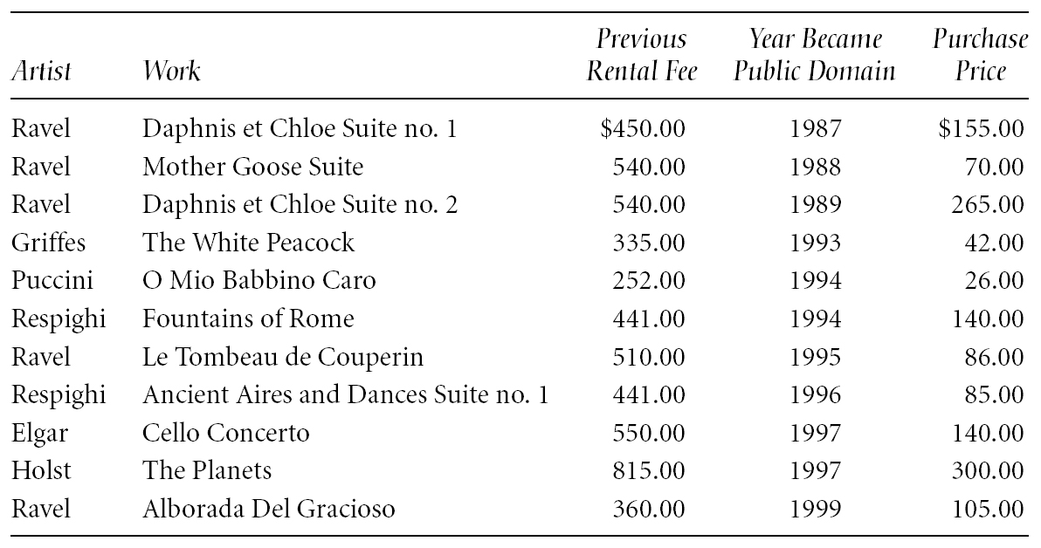
The question is, what is a reasonable length of time to grant authors and inventors exclusive rights to their creative works?
“Happy Birthday to You” is the most popular song in the world. Have you ever wondered why you almost never hear it sung on television? The reason is that the music publisher Clayton F. Summy Company (now a subsidiary of Time Warner) copyrighted the song in 1935, and television networks must pay Time Warner to air it. Time Warner collects about $2 million in royalties each year for public performances of “Happy Birthday to You”. Under the Copyright Term Extension Act of 1998, the song will remain copyrighted until at least 2030.

Protecting Intellectual Property

While the US Constitution gives Congress the right to grant authors and inventors exclusive rights to their creations, it does not elaborate on how these rights will be protected. Today there are four different ways in which individuals and organizations protect their intellectual property: trade secrets, trademarks/service marks, patents, and copyrights.

Trade Secret
A trade secret is a confidential piece of intellectual property that provides a company with a competitive advantage. Examples of trade secrets include formulas, processes, proprietary designs, strategic plans, customer lists, and other collections of information. The right of a company to protect its trade secrets is widely recognized by governments around the world. In order to maintain its rights to a trade secret, a company must take active measures to keep it from being discovered. For example, companies typically require employees with access to a trade secret to execute a confidentiality agreement.
An advantage of trade secrets is that they do not expire. A company never has to disclose a trade secret. Coca-Cola has kept its formula secret for more than 100 years. The value of trade secrets is in their confidentiality. Hence trade secrets are not an appropriate way to protect many forms of intellectual property. For example, it makes no sense for a company to make a movie a trade secret, because a company can only profit from a movie by allowing it to be viewed, which makes it no longer confidential. On the other hand, it is appropriate for a company to make the idea for a movie a trade secret.

Trademark, Service Mark

A trademark is a word, symbol, picture, sound, or color used by a business to identify goods. A service mark is a mark identifying a service. By granting a trademark or service mark, a government gives a company the right to use it and the right to prevent other companies from using it. Through the use of a trademark, a company can establish a “brand name.”
Society benefits from branding because branding allows consumers to have more confidence in the quality of the products they purchase. When a company is the first to market a distinctive product, it runs the risk that its brand name will become a common noun used to describe any similar product. When this happens, the company may lose its right to exclusive use of the brand name. Some trademarks that have become generic are “yo yo,” “aspirin,” “escalator,” “thermos,” and “brassiere.” Companies strive to ensure their marks are used as adjectives rather than nouns or verbs.

Patent
A patent is a way the US government provides an inventor with an exclusive right to a piece of intellectual property. A patent is quite different from a trade secret because a patent is a public document that provides a detailed description of the invention. The owner of the patent can prevent others from making, using, or selling the invention for the lifetime of the patent, which is currently 20 years. After the patent expires, anyone has the right to make use of its ideas.

Copyright
A copyright is how the US government provides authors with certain rights to original works that they have written. The owner of a copyright has five principal rights:
1. The right to reproduce the copyrighted work
2. The right to distribute copies of the work to the public
3. The right to display copies of the work in public
4. The right to perform the work in public
5. The right to produce new works derived from the copyrighted work.
Copyright owners have the right to authorize others to exercise these five rights with respect to their works. The owner of a copyright to a play may sell a license to a high school drama club that wishes to perform it. After a radio station broadcasts a song, it must pay the songwriter(s) and the composer(s) through a performance rights organization such as ASCAP, BMI, or SESAC. Copyright owners also have the right to prevent others from infringing on their rights to control the reproduction, distribution, display, performance, and production of works derived from their copyrighted work.

Reference
Lecture 12 slides: Intellectual Property Rights

Gao, Y. (2012). Ethics for the Information Age by Michael J. Quinn. World Libraries, 20(1).

